**Name: Adwait S Purao**

**UID: 2021300101**

**Batch: B2**

**Experiment no. : 1**

**Aim : Installation of Pop OS and running File , Directory ,Networking , Utility Commands**

**Theory :**

Linux is a free and open-source operating system, based on Unix, that is widely used for server, desktop, and embedded systems. Linux is known for its stability, security, and customization capabilities, and it is used by individuals, corporations, and governments worldwide. The source code for Linux is freely available, allowing users and developers to modify and distribute the operating system. The popularity of Linux has led to the development of many distributions, or "distros," each with its own unique features and target users. Some of the most popular distros include Ubuntu, Fedora, and CentOS.

Development: Linux was created in 1991 by Linus Torvalds, a student at the University of Helsinki, Finland. It has since grown into a massive project with contributions from thousands of developers all over the world.

Community: Linux is developed and maintained by a large and dedicated community of developers, users, and organizations. There is a strong sense of collaboration and cooperation within the community, with everyone working together to improve the operating system.

Open-Source: As mentioned earlier, Linux is open-source software, which means that the source code is available to everyone, allowing anyone to use, modify, and distribute the operating system. This has led to the creation of many different distributions and applications, making Linux a highly versatile platform.

Security: Linux is known for its security, thanks in part to its open-source development model. With the source code available for everyone to inspect, security vulnerabilities can be quickly identified and fixed. Additionally, the architecture of Linux is designed with security in mind, making it a secure platform for both personal and enterprise use.

Customization: Linux is highly customizable, with users able to modify everything from the look and feel of the operating system to the software that runs on it. There are countless tools and resources available for customizing Linux, making it a great choice for users who want a unique and personalized computing experience.

Wide Range of Applications: Linux can be used for a wide range of applications, from servers and supercomputers to smartphones and consumer electronics. It is a popular choice for web servers, database servers, and scientific computing, and is used by many businesses and organizations for mission-critical applications.

**Pop OS:**

**Pop!_OS is a free and open-source Linux distribution, based upon Ubuntu, and featuring a customized GNOME desktop environment known as COSMIC. The distribution is developed by American Linux computer manufacturer System76. Pop!_OS is primarily built to be bundled with the computers built by System76, but can also be downloaded and installed on most computers.[3]**

**Pop!_OS provides full out-of-the-box support for both AMD and Nvidia GPUs. It is regarded as an easy distribution to set up for gaming, mainly due to its built-in GPU support. Pop!_OS provides default disk encryption, streamlined window and workspace management, keyboard shortcuts for navigation as well as built-in power management profiles. The latest releases also have packages that allow for easy setup for TensorFlow and CUDA.[4][5]**

**Pop!_OS is maintained primarily by System76, with the release version source code hosted in a GitHub repository. Unlike many other Linux distributions, it is not community-driven, although outside programmers can contribute, view and modify the source code. They can also build custom ISO images and redistribute them under another name**

**Reasons to use POP OS:**

1. **Separate NVIDIA/AMD ISO**

In case you have a system with Nvidia GPU, it is not feasible to make it work using Nouveau (an open-source driver for Nvidia cards).

Well, you get a working display, but you cannot utilize the benefits of your graphics card.

For instance, you will encounter stuttering and performance issues with almost every task that needs to utilize the GPU.

Hence, the proprietary Nvidia drivers are the only solution to make things right.

And, to conveniently add the proprietary driver out of the box, the distro needs to include it in the ISO itself or offer a separate ISO with Nvidia’s latest available proprietary driver.

While you can always manually install the proprietary drivers, it is not always a flawless experience.

The procedure should be similar to that of installing Nvidia drivers in Linux Mint for most of the popular Linux distros if you are curious.

Driver Manager | Linux Mint (Cinnamon)

Note that, at times, you will need to troubleshoot or re-install the correct (or an older driver version of the driver) to use Nvidia graphics properly.

But, if you get a separate ISO for Nvidia-powered systems, or an Nvidia graphics installation mode (like Zorin OS), it eliminates the hassle of installing Nvidia drivers manually.

This is not just about the ease of use, but Pop!_OS always works out of the box with the help Nvidia ISOs offered.

I have had issues with Linux Mint, Ubuntu, and a few other distributions when I tried to manually install the proprietary drivers. So, Pop!_OS is a breeze to set up for my system with Nvidia graphics.

2. **Automatic Tiling Manager**

Without a tiling manager, you need to constantly drag and drop (and move) your active windows to organize them for quick access.

So, a window tiling manager makes it convenient to automatically organize the active windows of any application that you launch.

Of course, the experience with a tiling manager will differ as per your screen size, but even if you have a modest 27-inch size display, it should be a noticeable experience.

I find myself using it all the time, even without a big monitor (or a dual-monitor setup).

I have never used it on a laptop, but at the end of the day, having an automatic window tiling manager (that you can enable/disable) sounds like a useful feature.

It helps with enhancing your multi-tasking capabilities without necessarily moving to different workspaces.

3. **Ease of Use**

Why do you think Ubuntu is one of the best Linux distributions?

It manages to offer an easy-to-use modern desktop experience for years now.

Impressively, System76 has managed to polish the user experience in Pop!_OS up a notch on top of Ubuntu.

Hence, Pop!_OS is not just another Ubuntu distro, but the presence of an application launcher, application library, dock, workspace customizations, and various other optimizations lead to a unique desktop experience.

For my use-case, it feels better than Ubuntu. Not to forget, it also includes some of its tools like Popsicle that comes in handy later down the road.

4. **Newer Linux Kernel**

Pop!_OS 21.10 featuring Linux Kernel 5.15.8

Ubuntu may not feature the latest and greatest Linux Kernel, especially when it comes to LTS releases.

However, Pop!_OS tries its best to offer the latest Linux Kernel releases even for the LTS releases. For instance, Ubuntu 20.04.3 LTS packs in Linux Kernel 5.11, but Pop!_OS 20.04 LTS features Linux Kernel 5.13.

For most users, this may not be a big deal, but Pop!_OS pushes newer Linux Kernel faster than most other Linux distributions.

If you want your latest and greatest hardware to work well with Linux distros, Pop!_OS is a fantastic bet.

5. **Application Launcher**

Application launcher comes in incredibly handy to quickly launch an app or navigate between active windows.

The ability to invoke the launcher using a shortcut (or maybe a macro linked to it, as I use it) makes it one of the quickest ways to launch applications and navigate between them.

Of course, you can install tools like Ulauncher to achieve the same. However, having it pre-configured and working out of the box without any troubleshooting is convenient.

6. **Fast Upgrade Process**

Even though upgrading Linux distributions is usually hassle-free, Pop!_OS tries its best to refine and improve the upgrade process with every update.

For instance, with Pop!_OS 21.10, they introduced improvements that would prevent conflicts in the upgrade process and make it a seamless process.

In fact, I upgraded from Pop!_OS 21.04 to 21.10 in a few clicks without any issues.

7. **Thrives to Improve the Modern Desktop Experience**

Pop!_OS may not be a lightweight Linux distro, but it focuses on providing a top-notch experience for modern desktop users.

While there are plenty of good Linux distributions for older computers, it is equally important to aim for newer-gen hardware.

Pop!_OS does that incredibly well considering System76 also tests the distribution on latest hardware configurations with their laptops.

In addition, Pop!_OS also offers out-of-the-box tweaks that makes things easy for a user in terms of OS experience. While Linux is all about tweaking and taking control of your system, Pop!_OS seems to be succeeding in making it a mainstream option and a viable alternative to Ubuntu that could prove to be better for some.

**Uninstalling Virtual Box:**

Command: sudo apt-get remove --purge virtual box

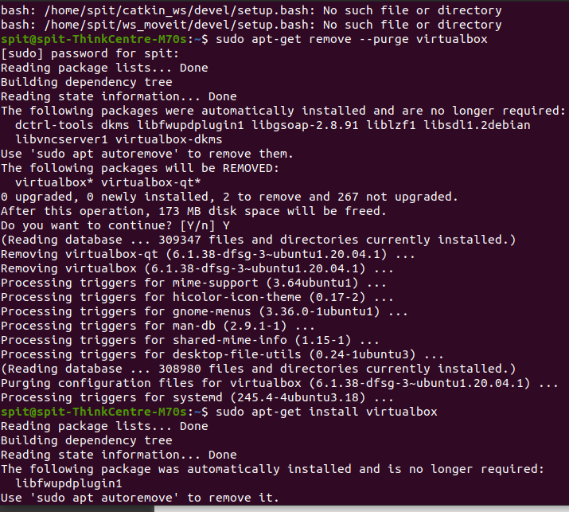

**Installing Virtual Box:**

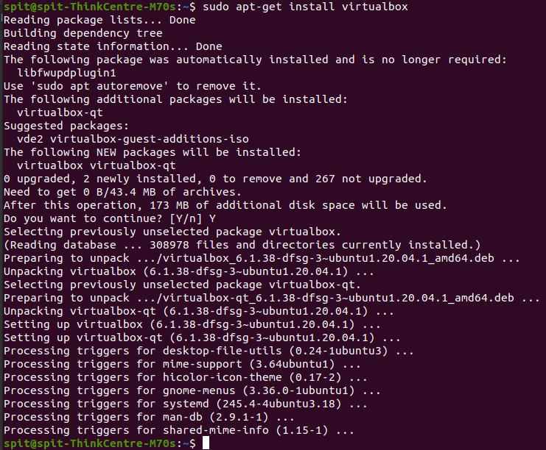

Linux Commands:

**Linux directory commands**

1. pwd Command

The [pwd](https://www.javatpoint.com/linux-pwd) command is used to display the location of the current working directory.

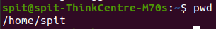

2. mkdir Command

The [mkdir](https://www.javatpoint.com/linux-mkdir) command is used to create a new directory under any directory.



3. rmdir Command

The [rmdir](https://www.javatpoint.com/linux-rmdir) command is used to delete a directory.



4. ls Command

The [ls](https://www.javatpoint.com/linux-ls) command is used to display a list of content of a directory.

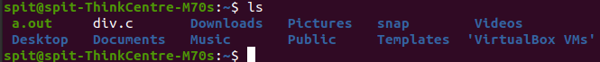

5. cd Command

The [cd](https://www.javatpoint.com/linux-cd) command is used to change the current directory.

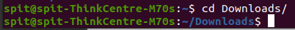

6. **cp Command**

The [cp](https://www.javatpoint.com/linux-cp) command is used to copy a file or directory.

**Syntax:**

To copy in the same directory:

cp **<existing** file name**>** **<new** file name**>**

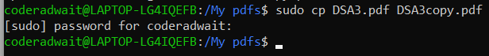

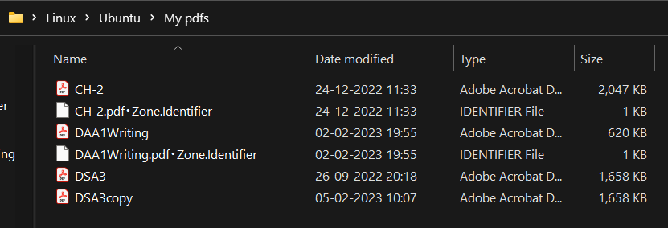

1. **mv Command**

The [mv](https://www.javatpoint.com/linux-mv) command is used to move a file or a directory form one location to another location.

**Syntax:**

mv **<file** name**>** **<directory** path**>**

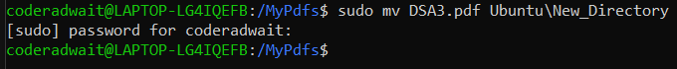

1. rm Command

rm stands for **remove** here. rm command is used to remove objects such as files, directories, symbolic links and so on from the file system like UNIX. To be more precise, rm removes references to objects from the filesystem, where those objects might have had multiple references (for example, a file with two different names). **By default, it does not remove directories.**

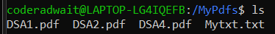

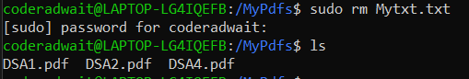

9. head Command

The [head](https://www.javatpoint.com/linux-head) command is used to display the content of a file. It displays the first 10 lines of a file.



**10.** id Command

The [id](https://www.javatpoint.com/linux-id-command) command is used to display the user ID (UID) and group ID (GID).



**Linux Networking commands**

**1.** ip Command

Linux [ip](https://www.javatpoint.com/linux-ip) command is an updated version of the ipconfig command. It is used to assign an IP address, initialize an interface, disable an interface.

Syntax:

ip a or ip addr

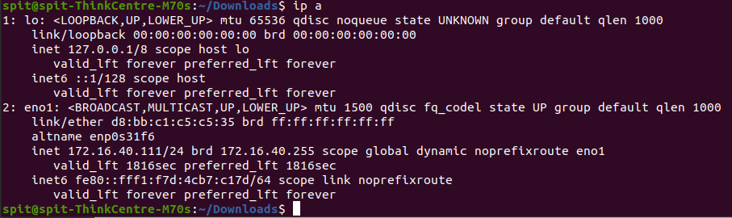

2. ping Command

The [ping](https://www.javatpoint.com/linux-ping) command is used to check the connectivity between two nodes, that is whether the server is connected. It is a short form of "Packet Internet Groper."

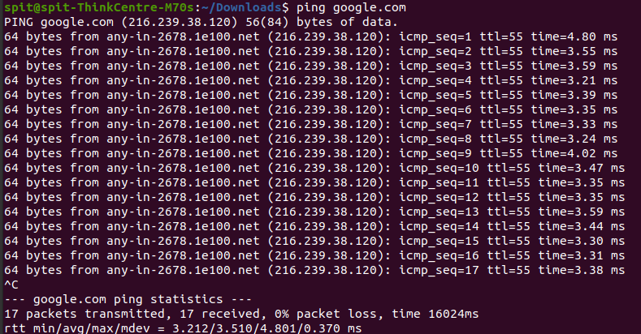

3. host Command

The [host](https://www.javatpoint.com/linux-host) command is used to display the IP address for a given domain name and vice versa. It performs the DNS lookups for the DNS Query.

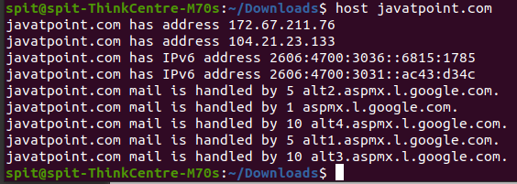

1. **ifconfig command**

You can use the **ifconfig** command to assign an address to a network interface and to configure or display the current network interface configuration information. The **ifconfig** command must be used at system startup to define the network address of each interface present on a system. After system startup, it can also be used to redefine an interfaces address and its other operating parameters. The network interface configuration is held on the running system and must be reset at each system restart. The **ifconfig** command interprets the **IFF_MULTICAST** flag and prints its value if it is set.

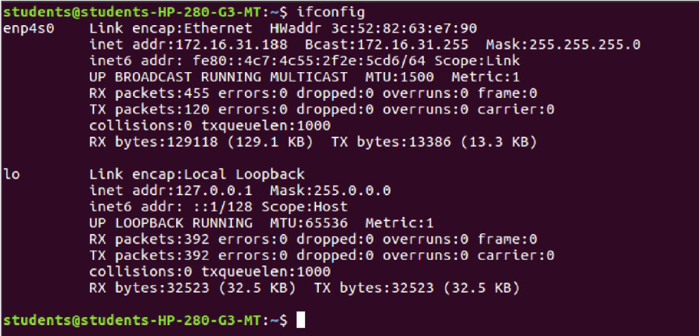

1. **Nslookup Command**

Name server lookup (nslookup) is a command-line tool that lets you find the internet protocol (IP) address or domain name system (DNS) record of a specific hostname. This command also allows reverse DNS lookup by inputting the IP addresses of the corresponding domains.

The nslookup tool is useful for DNS-related tasks, such as server testing or troubleshooting issues. To use this tool, type “nslookup” into a command-line interface (CLI) such as the Command Prompt on Windows or Terminal on Linux and macOS.

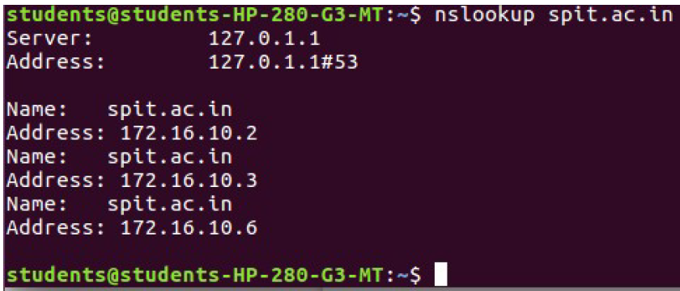

1. **Traceroute**

Linux traceroute command is a network troubleshooting utility that helps us determine the number of hops and packets traveling path required to reach a destination. It is used to display how the data transmitted from a local machine to a remote machine. Loading a web page is one of the common examples of the traceroute. A web page loading transfers data through a network and routers. The traceroute can display the routes, IP addresses, and hostnames of routers over a network. It can be useful for diagnosing network issues.

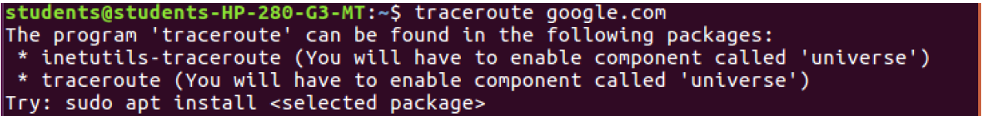

1. **Sudo apt-get install**

sudo apt-get install command is used to download the latest version of your desired application from an online software repository pointed to by your sources.list configuration file and and install that application on your Linux machine.

A good analogy is to think of your computer as a factory and the apt-get command as the manager in that factory who is responsible for the installation of new equipment, removal of equipment that is no longer needed, and update desired equipment to their latest versions, while maintaining records of the equipment names and versions which are currently present in the factory.

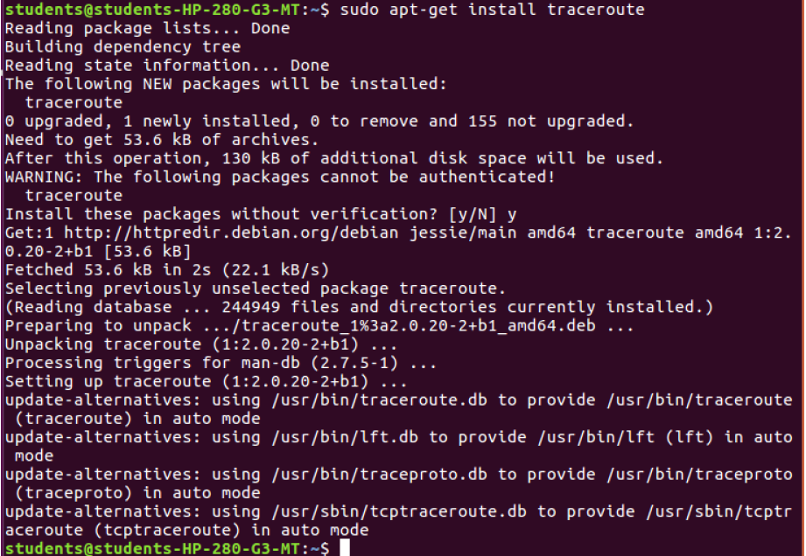

1. ARP command

The arp stands for the “Address Resolution Protocol” and it makes changes in the kernel’s table which contains the arp addresses.

The arp command allows users to manipulate the neighbor cache or ARP table. It is contained in the Net-tools package along with many other notable networking commands (such as ifconfig). The arp command has since been replaced by the ip neighbour command**.**

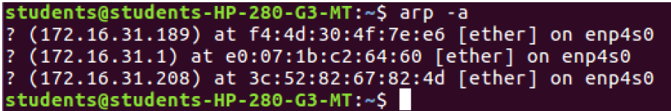

1. netstat

Linux netstat command refers to the network statistics.

It provides statistical figures about different interfaces which include open sockets, routing tables, and connection information.

**Syntax:**

**netstat**

**Output:**

Observe the output displaying all the open sockets.

Variations in netstat command

Below are few variations of the netstat command used.

1) To display the programs

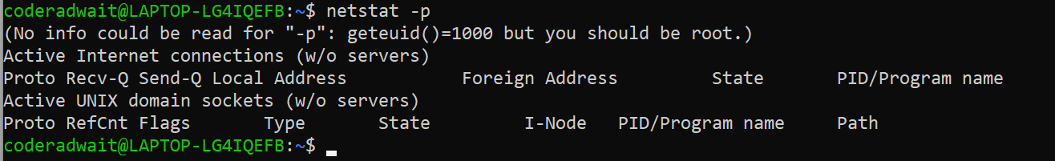

1. **Dig Command**

Linux dig command stands for Domain Information Groper. This command is used in DNS lookup to query the DNS name server. It is also used to troubleshoot DNS related issues.

It is mainly used to verify DNS mappings, MX Records, host addresses, and all other DNS records for a better understanding of the DNS topography.

This command is an improvised version of nslookup command.

**Syntax:**

dig <domainName>

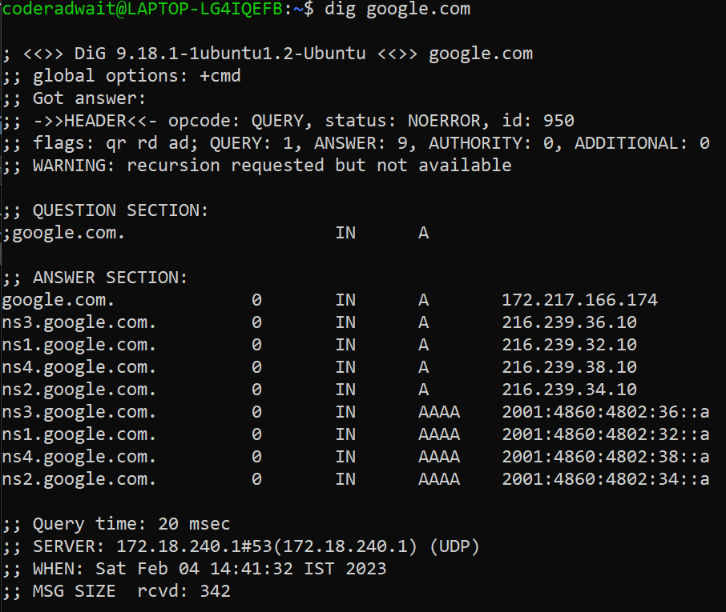

**Linux Utility Commands**

1. **find Command**

The [find](https://www.javatpoint.com/linux-find) command is used to find a particular file within a directory. It also supports various options to find a file such as byname, by type, by date, and more.

The following symbols are used after the find command:

(.) : For current directory name

(/) : For root

**Syntax:**

1. find . -name "*.pdf"

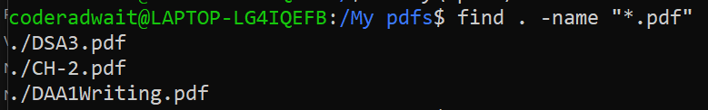

1. **locate Command**

The [locate](https://www.javatpoint.com/linux-locate) command is used to search a file by file name. It is quite similar to find command; the difference is that it is a background process. It searches the file in the database, whereas the find command searches in the file system. It is faster than the find command. To find the file with the locates command, keep your database updated.

**Syntax:**

locate **<file** name**>**

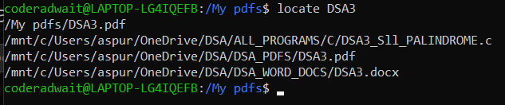

1. **date Command**

The [date](https://www.javatpoint.com/linux-date) command is used to display date, time, time zone, and more.

**Syntax:**

1. date

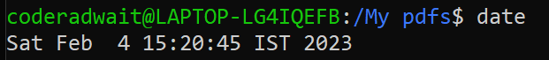

1. **cal Command**

The [cal](https://www.javatpoint.com/linux-cal) command is used to display the current month's calendar with the current date highlighted.

**Syntax:**

* 1. cal**<**

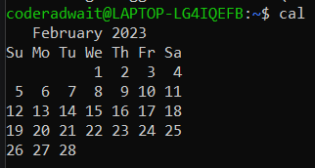

1. **sleep Command**

The [sleep](https://www.javatpoint.com/linux-sleep) command is used to hold the terminal by the specified amount of time. By default, it takes time in seconds.

**Syntax:**

sleep **<time>**

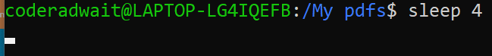

1. **time Command**

The [time](https://www.javatpoint.com/linux-time) command is used to display the time to execute a command.

**Syntax:**

* 1. time

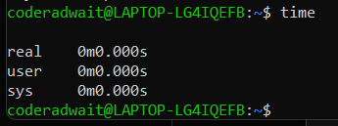

1. **df Command**

The [df](https://www.javatpoint.com/linux-df) command is used to display the disk space used in the file system. It displays the output as in the number of used blocks, available blocks, and the mounted directory.

**Syntax:**

df

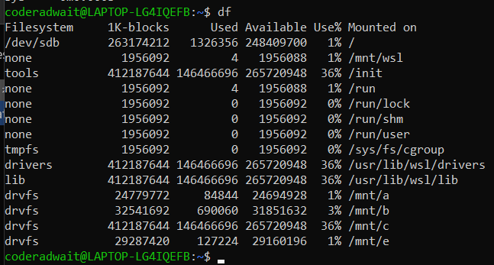

1. **mount Command**

The [mount](https://www.javatpoint.com/linux-mount) command is used to connect an external device file system to the system's file system.

**Syntax:**

mount -t type **<device>** **<directory>**

1. **clear Command**

Linux **clear** command is used to clear the terminal screen.

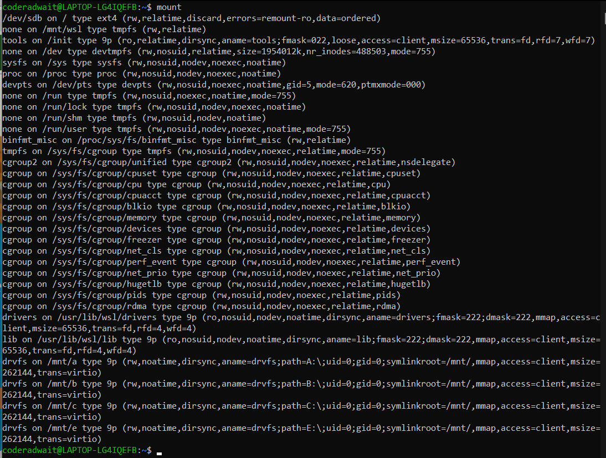

**Syntax:**

clear

Before:

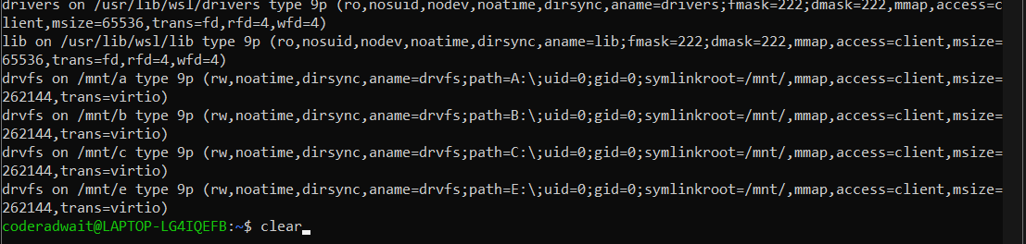

After:

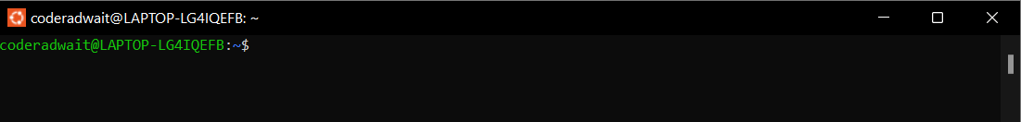

1. **exit Command**

Linux [exit](https://javatpoint.com/linux-exit-command) command is used to exit from the current shell. It takes a parameter as a number and exits the shell with a return of status number.

**Syntax:**

exit

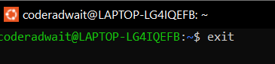

Linux File Commands

* 1. touch Command

The [touch](https://www.javatpoint.com/linux-touch) command is used to create empty files. We can create multiple empty files by executing it once.

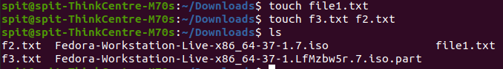

* 1. cat Command

The [cat](https://www.javatpoint.com/linux-cat) command is a multi-purpose utility in the Linux system. It can be used to create a file, display content of the file, copy the content of one file to another file, and more.

Syntax:

cat [OPTION]... [FILE]...

Create a file, execute it as follows:

cat **>** **<file** name**>**

// Enter file content

Press "CTRL+ D" keys to save the file. To display the content of the file, execute it as follows:

cat **<file** name**>**

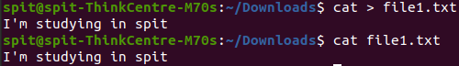

* 1. tail command

It is the complementary of head command.The tail command, as the name implies, print the last N number of data of the given input. By default it prints the last 10 lines of the specified files. If more than one file name is provided then data from each file is precedes by its file name.

**-n num:** Prints the last ‘num’ lines instead of last 10 lines. **num** is mandatory to be specified in command otherwise it displays an error. This command can also be written as without symbolizing ‘n’ character but ‘-‘ sign is mandatory.



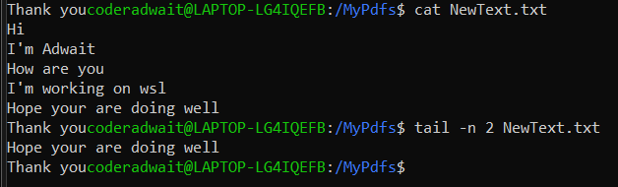

* 1. more Command

more command is used to view the text files in the command prompt, displaying one screen at a time in case the file is large (For example log files). The more command also allows the user do scroll up and down through the page

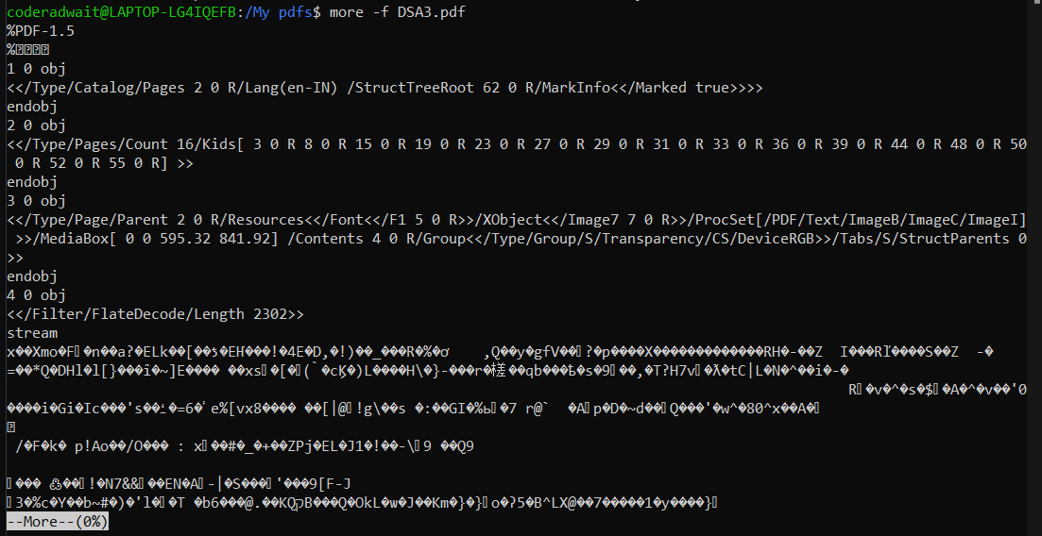

* 1. **less Command**

The less command is a Linux terminal pager that shows a file's contents one screen at a time. It is useful when dealing with a large text file because it doesn't load the entire file but accesses it page by page, resulting in fast loading speeds.



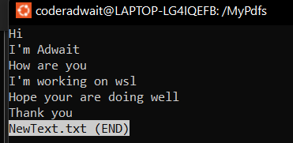

* 1. **wc Command**

It is used to find out number of lines, word count, byte and characters count in the files specified in the file arguments.

By default it displays four-columnar output.

First column shows number of lines present in a file specified, second column shows number of words present in the file, third column shows number of characters present in file and fourth column itself is the file name which are given as argument.

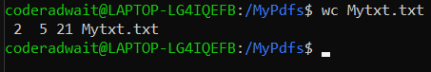

* 1. **uniq Command**

The uniq command in Linux is a command-line utility that reports or filters out the repeated lines in a file.

In simple words, uniq is the tool that helps to detect the adjacent duplicate lines and also deletes the duplicate lines. uniq filters out the adjacent matching lines from the input file(that is required as an argument) and writes the filtered data to the output file.

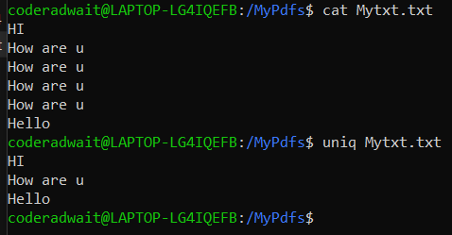

* 1. **Tac Command**

tac command in Linux is used to concatenate and print files in reverse. This command will write each FILE to standard output, the last line first. When no file is specified then this command will read the standard input.

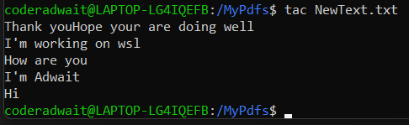

* 1. **Sort Command**

SORT command is used to sort a file, arranging the records in a particular order. By default, the sort command sorts file assuming the contents are ASCII. Using options in the sort command can also be used to sort numerically.

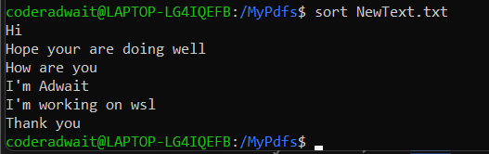

* 1. **Grep Command**

The grep filter searches a file for a particular pattern of characters, and displays all lines that contain that pattern. The pattern that is searched in the file is referred to as the regular expression (grep stands for global search for regular expression and print out).

**Syntax:**

**grep [options] pattern [files]**

* + 1. **Case insensitive search : The -i option enables to search for a string case insensitively in the given file. It matches the words like “UNIX”, “Unix”, “unix”.**

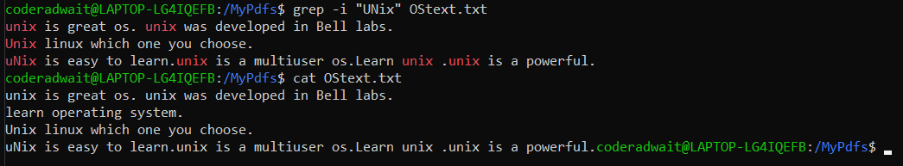

**11. File Command**

file command is used to determine the type of a file. .file type may be of human-readable(e.g. ‘ASCII text’) or MIME type(e.g. ‘text/plain; charset=us-ascii’). This command tests each argument in an attempt to categorize it.

It has three sets of tests as follows:

* filesystem test: This test is based on the result which returns from a stat system call. The program verifies that if the file is empty, or if it’s some sort of special file. This test causes the file type to be printed.
* magic test: These tests are used to check for files with data in particular fixed formats.
* language test: This test search for particular strings which can appear anywhere in the first few blocks of a file.

Options:

* -b, –brief : This is used to display just file type in brief mode.

Syntax:

**file -b filename**



* option : **Command displays the all files’s file type.**

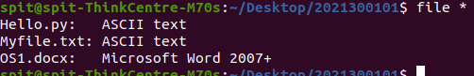

**12. Append text to the end of file**

In Linux, the echo command can be used for displaying a line of string/text that is passed as the arguments. This command is a built-in that is mostly and widely used in various batch files and shell scripts to outcome status test to a file and screen.

Syntax of the echo command

1. echo [option] [string]



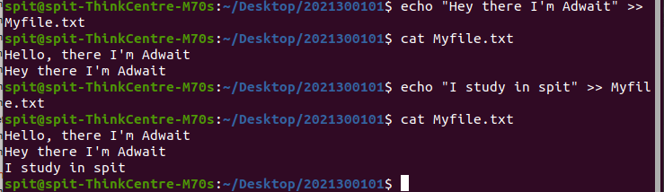

**13. Appending one file to another**

The >> operator redirects output to a file. If the mentioned file doesn’t exist the file is created and then the text is appended to the file. When we use it with cat command it appends the first file to the second and the changes are made in the second file and the first file remains unchanged.

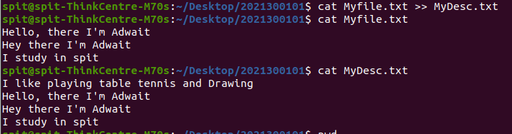

**14. chmod Command**

In Unix-like operating systems, the **chmod** command is used to change the access mode of a file.  
The name is an abbreviation of **change mode**.

**Syntax :**

chmod [reference][operator][mode] file...

Options:

The chmod command supports the following command-line options:

-c, --changes: It is similar to the verbose option, but the difference is that it is reported if a change has been made.

-f, --silent, --quiet: It is used to suppress the error messages.

-v, --verbose: It is used to display a diagnostic for every processed file.

--no-preserve-root: It is used for not treating the backslash symbol ('/'), especially (the default).

--preserve-root: If this option is used, it will fail to operate recursively on backslash ('/').

--reference=RFILE: It is used to specify the RFILE's mode alternatively MODE values.

-R, --recursive: It is used to change files and directories recursively.

--help: It is used to display the help manual having a brief description of usage and support options.

--version: It is used to display the version information.

**the user can read, write, and execute it;**

1. the **u**ser can **r**ead, **w**rite, and e**x**ecute it;
2. members of your **g**roup can **r**ead and e**x**ecute it; and
3. **o**thers may only **r**ead it.

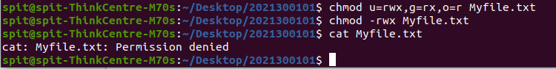

**15. ps Command**

Linux provides us a utility called ps for viewing information related with the processes on a system which stands as abbreviation for “Process Status”. ps command is used to list the currently running processes and their PIDs along with some other information depends on different options. It reads the process information from the virtual files in /proc file-system. /proc contains virtual files, this is the reason it’s referred as a virtual file system.

ps provides numerous options for manipulating the output according to our need.

Syntax –

ps [options]

1. Simple process selection : **Shows the processes for the current shell –**

PID – the unique process ID   
TTY – terminal type that the user is logged into   
TIME – amount of CPU in minutes and seconds that the process has been running   
CMD – name of the command that launched the process.

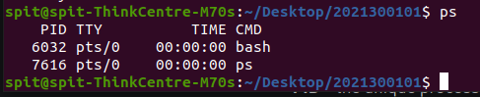

**2.**View Processes : View all the running processes use either of the following option with ps –

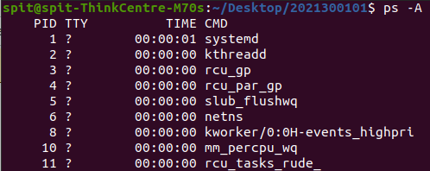

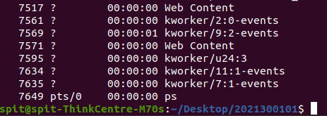

View all the processes except session leaders :

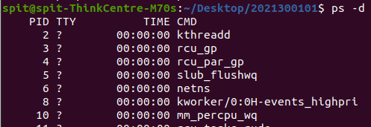

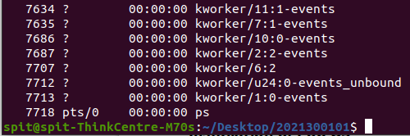

**16. alias**

The alias command lets you give your own name to a command or sequence of commands. You can then type your short name, and the shell will execute the command or sequence of commands for you.

alias cls=clear

This sets up an alias called cls . It will be another name for clear . When you type cls, it will clear the screen just as though you had typed clear .

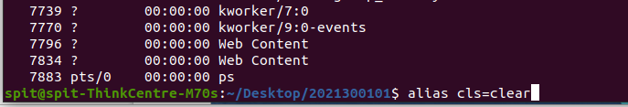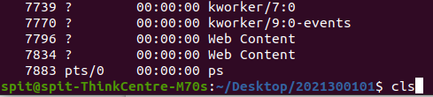

**17. curl Command**

The curl command is a tool to retrieve information and files from Uniform Resource Locators (URLs) or internet addresses.

The curl command may not be provided as a standard part of your Linux distribution. Use apt-get to install this package onto your system if you’re using Ubuntu or another Debian-based distribution. On other Linux distributions, use your Linux distribution’s package management tool instead.

sudo apt-get install curl

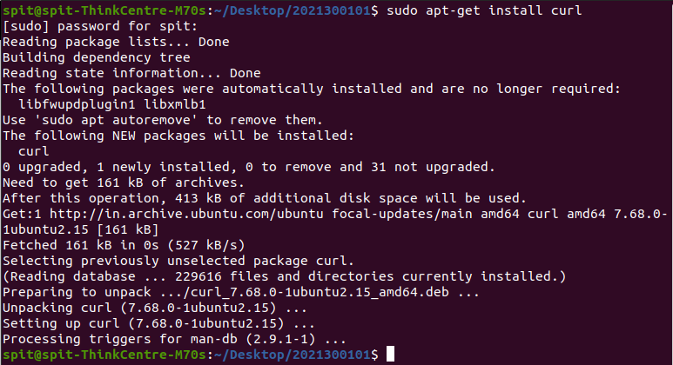

**18. finger**

The finger command gives you a short dump of information about a user, including the time of the user’s last login, the user’s home directory, and the user account’s full name.

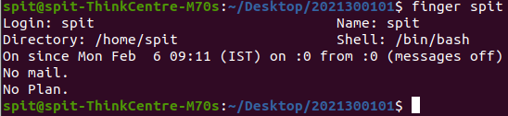

**19. free**

The free command gives you a summary of the memory usage with your computer. It does this for both the main Random Access Memory (RAM) and swap memory. The -h (human) option is used to provide human-friendly numbers and units. Without this option, the figures are presented in bytes.

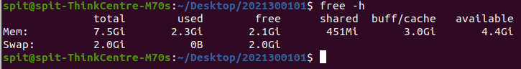

**20. groups**

The groups command tells you which groups a user is a member of.



**21. history**

The history command lists the commands you have previously issued on the command line. You can repeat any of the commands from your history by typing an exclamation point ! and the number of the command from the history list.

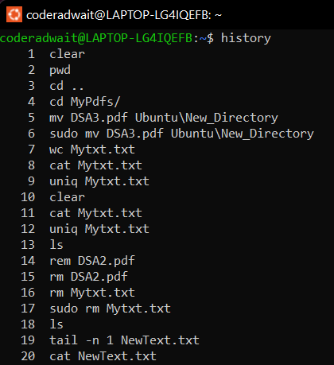

22. **man**

The man command displays the “man pages” for a command in less . The man pages are the user manual for that command. Because man uses less to display the man pages, you can use the search capabilities of less.



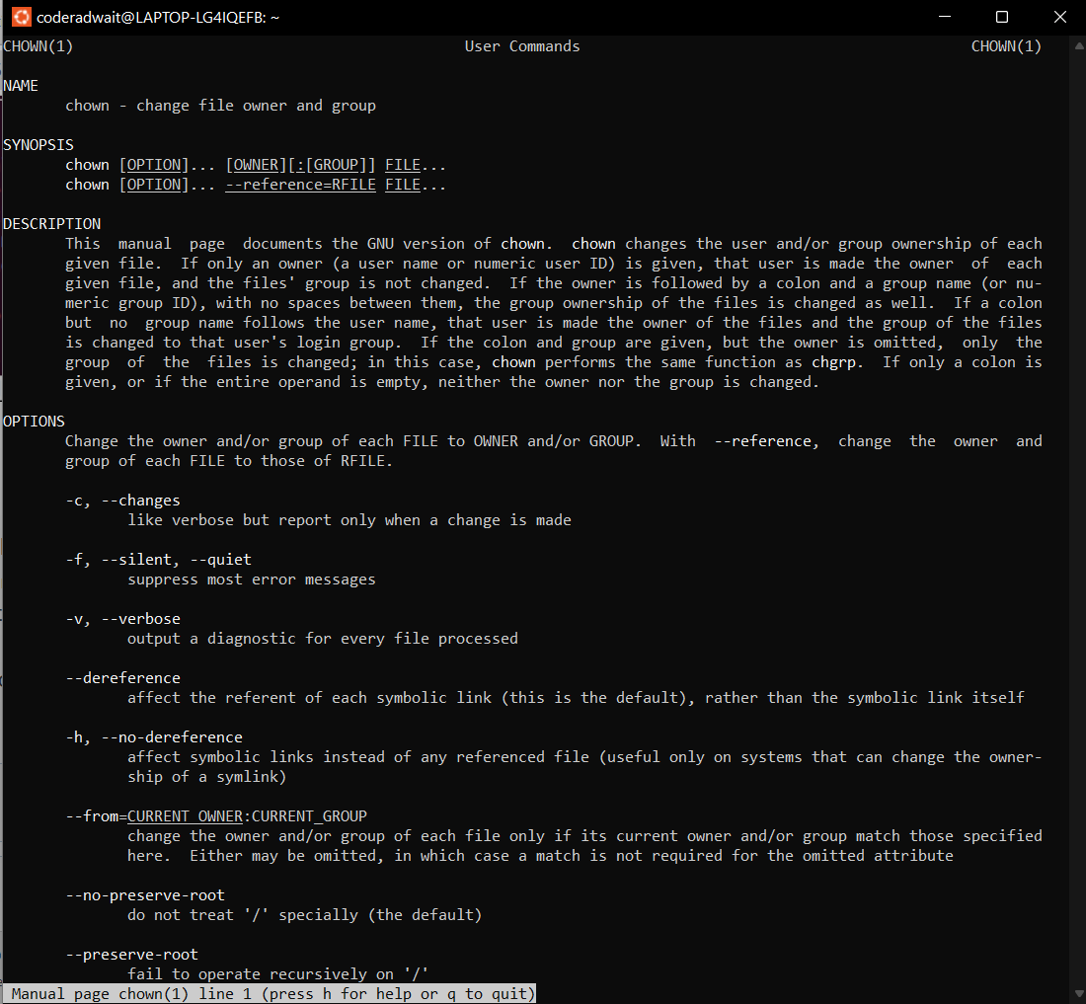

**Installation of Pop OS**

**Site of Pop OS**

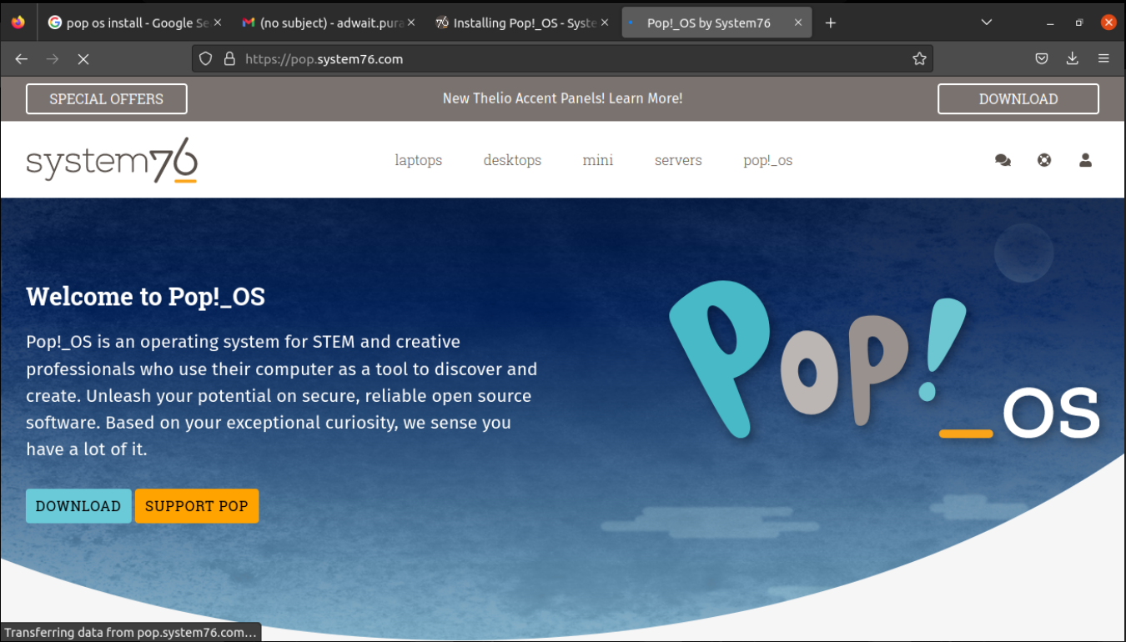

**Initializing Virtual Box**

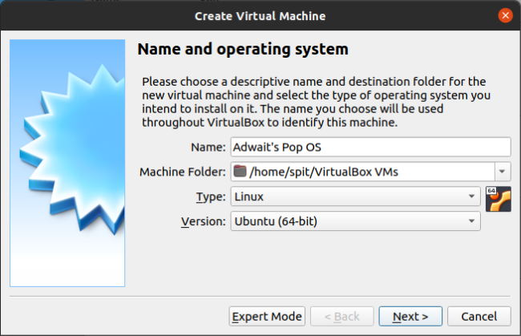

**Initializing Memory Size**

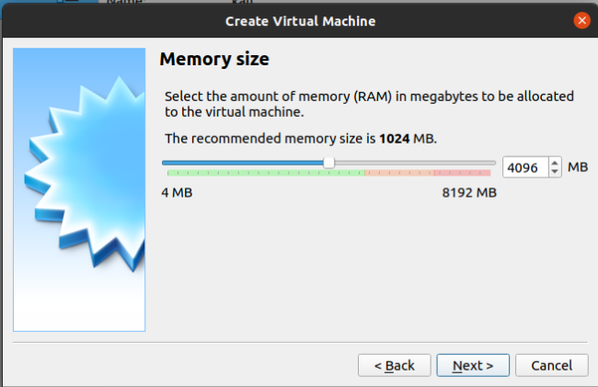

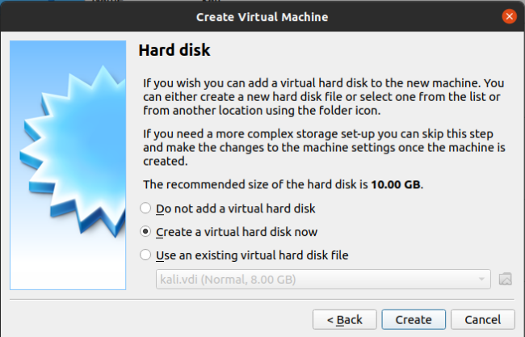

**Choosing the file type of Hard-disk**

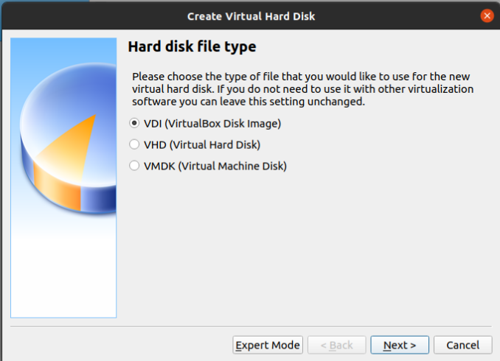

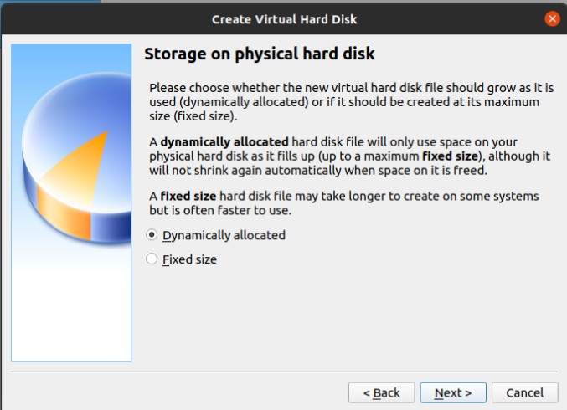

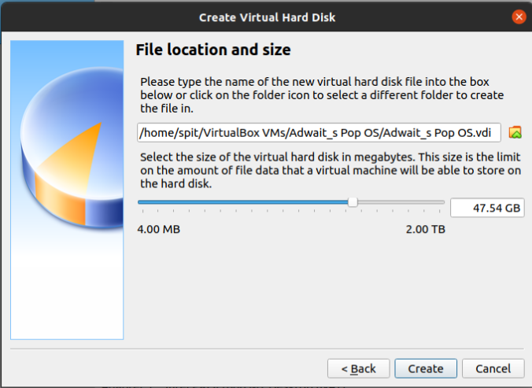

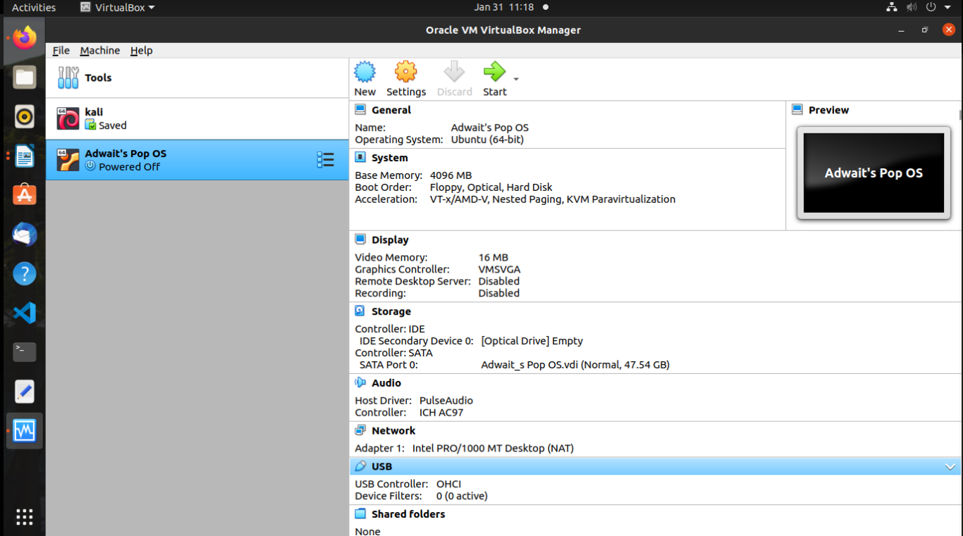

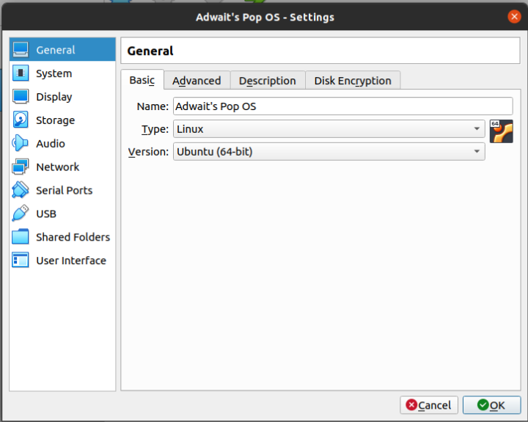

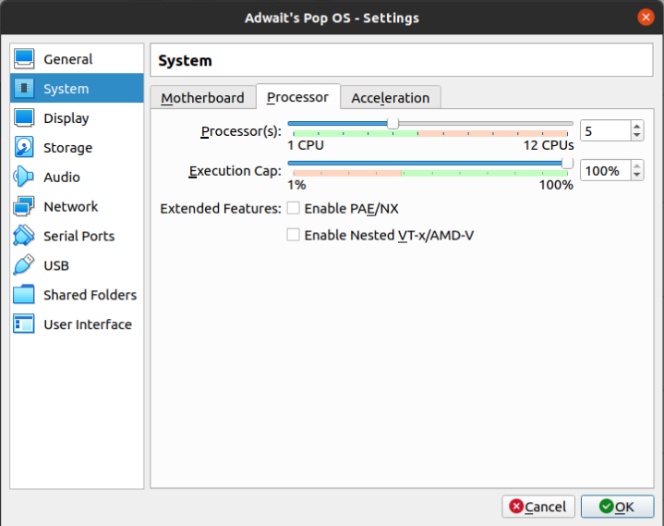

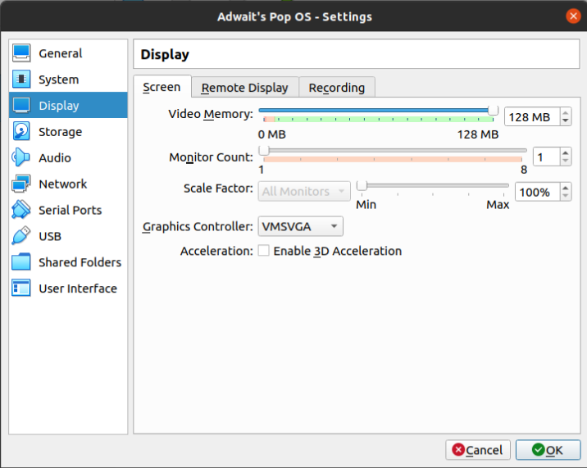

**Select and start Pop OS**

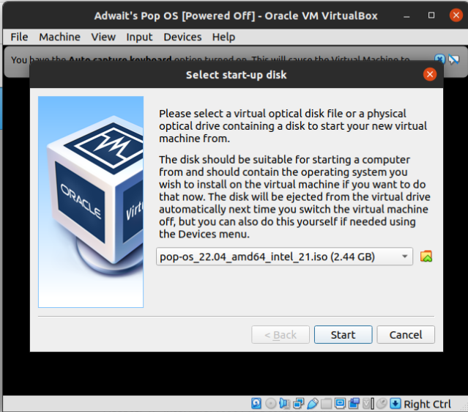

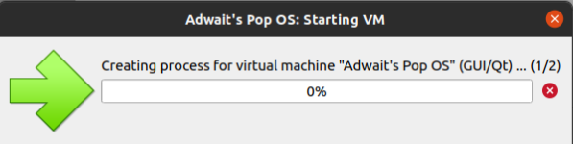

**Click on cross.**

**Selecting the start-up disk**

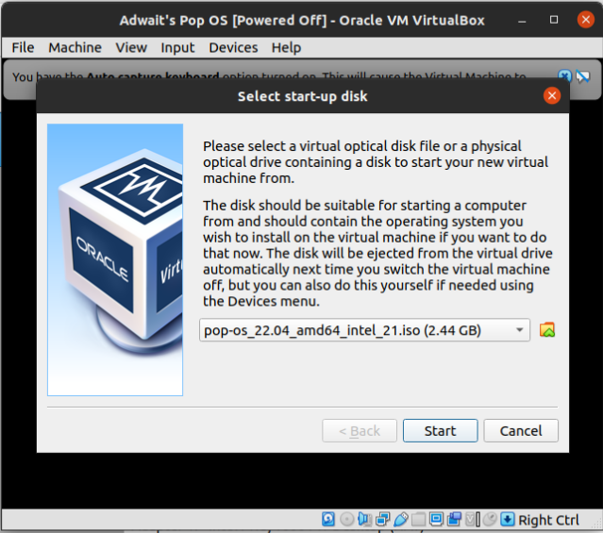

**Starting display of Pop OS**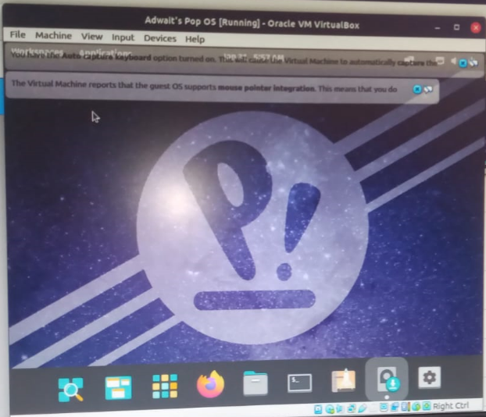

**Select English Language**

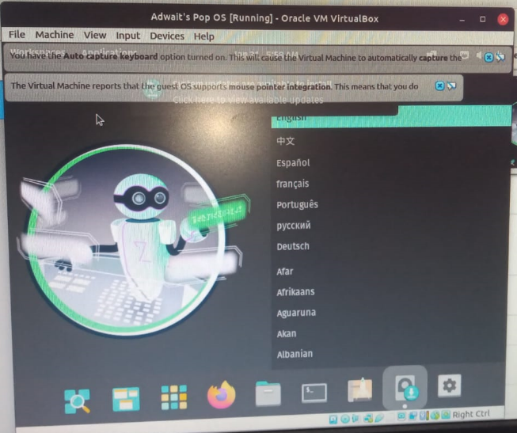

**Select Country as United States**

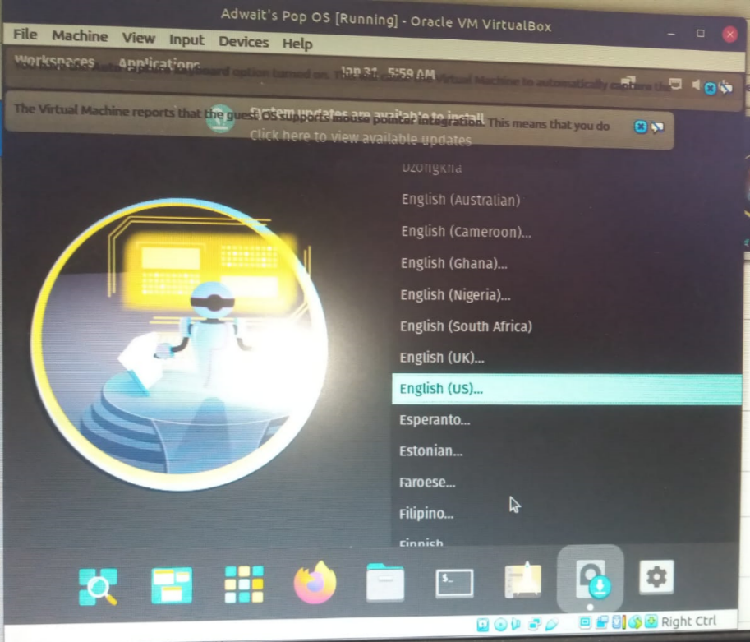

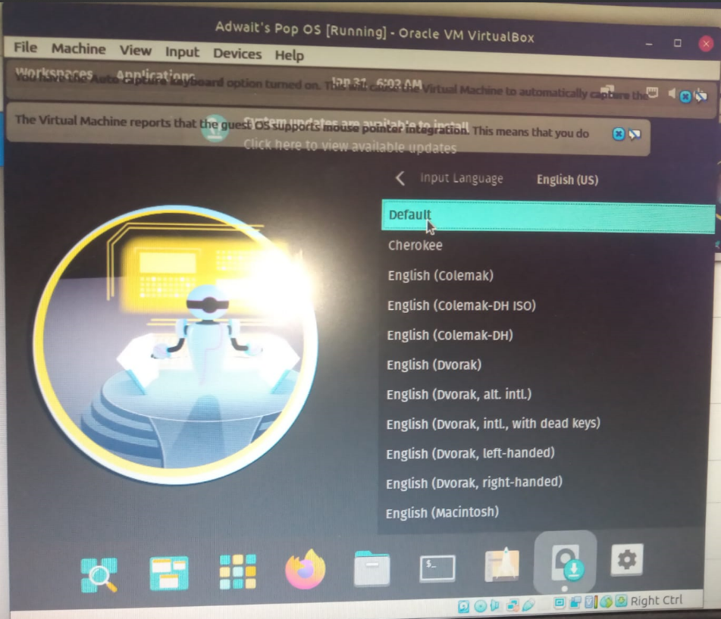

**Click Clean Install Pop OS**

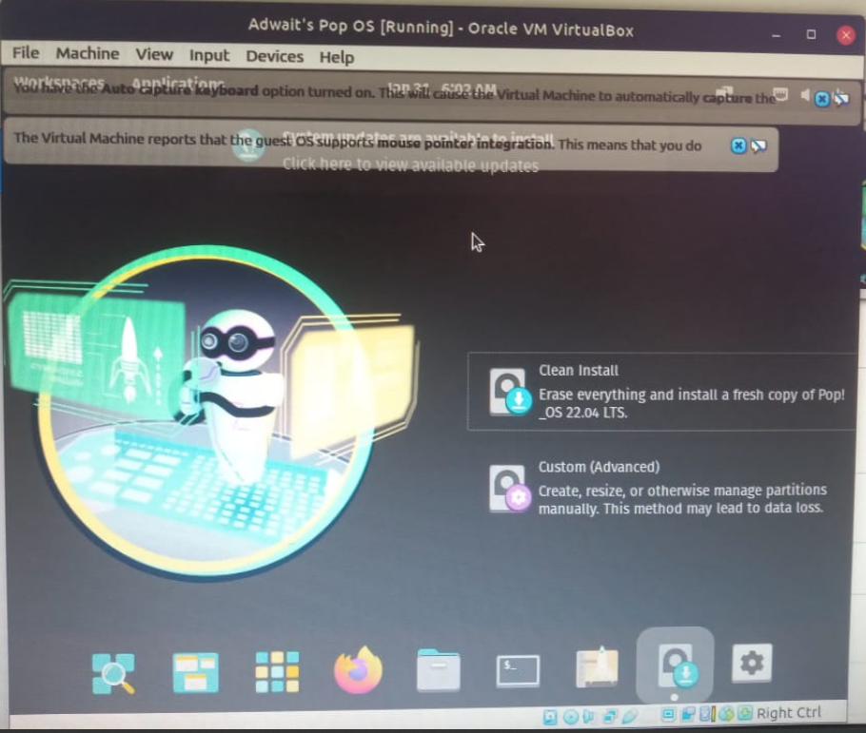

**Click on ATA VBOX HARDISK**

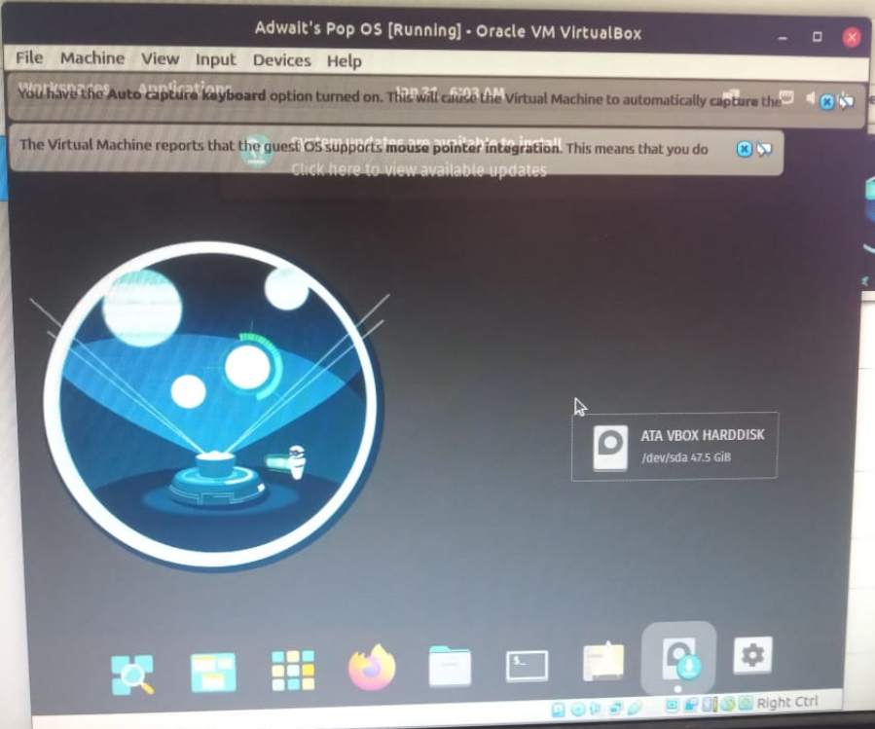

**Enter your username.**

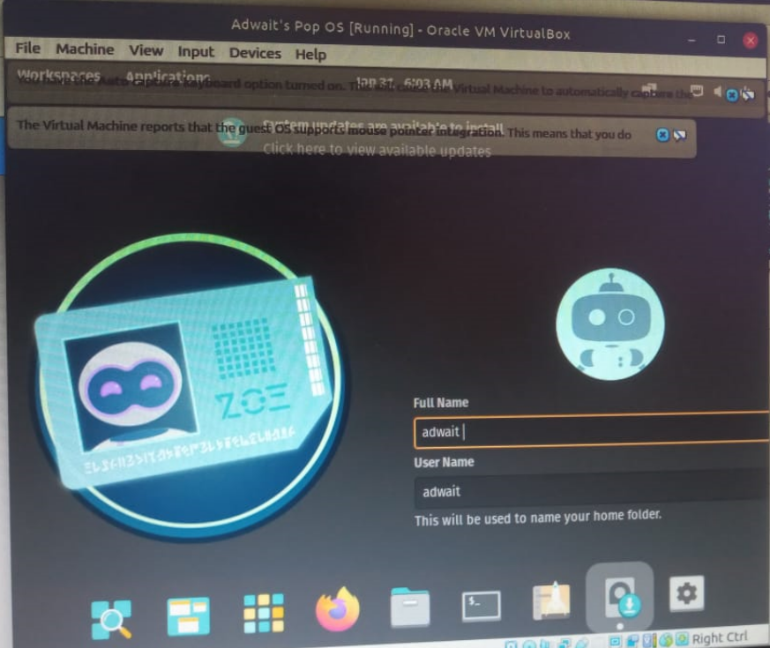

**Set your password**

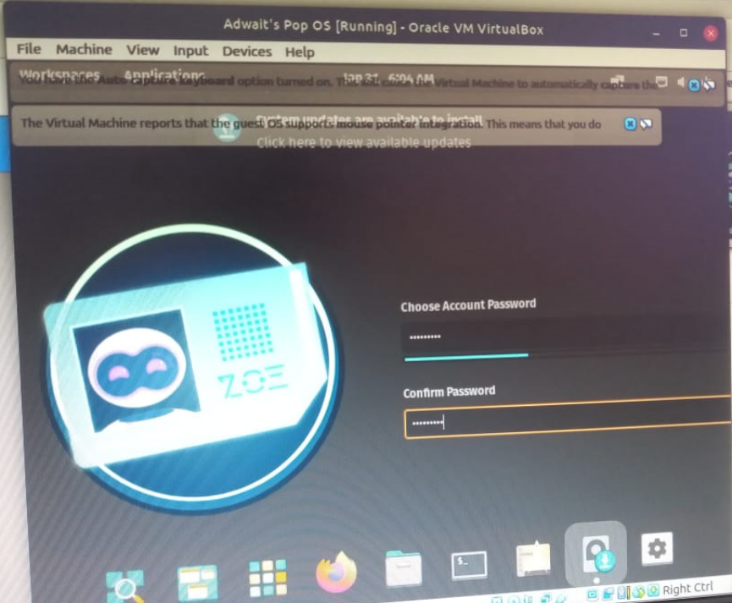

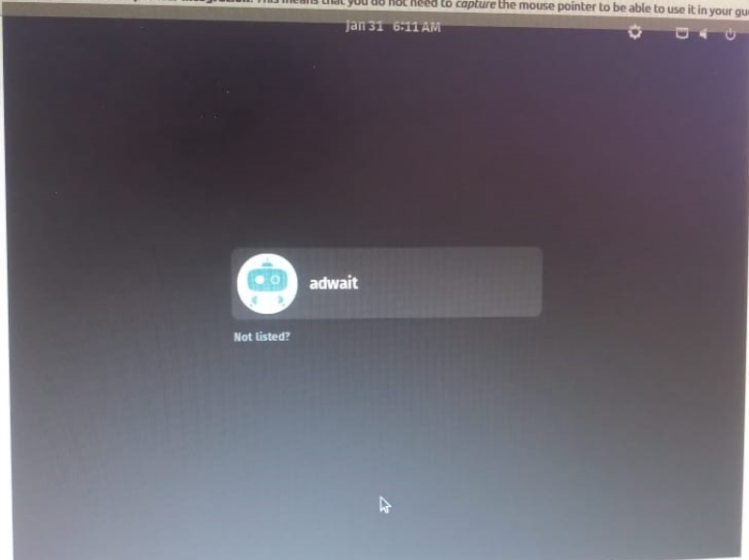

**Now click on the icon and enter the password**

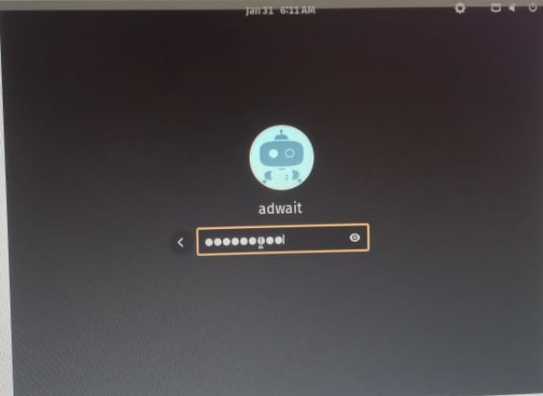

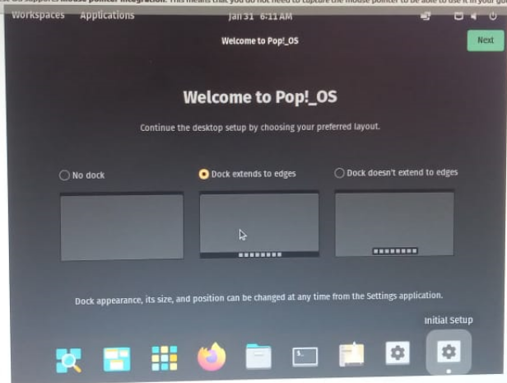

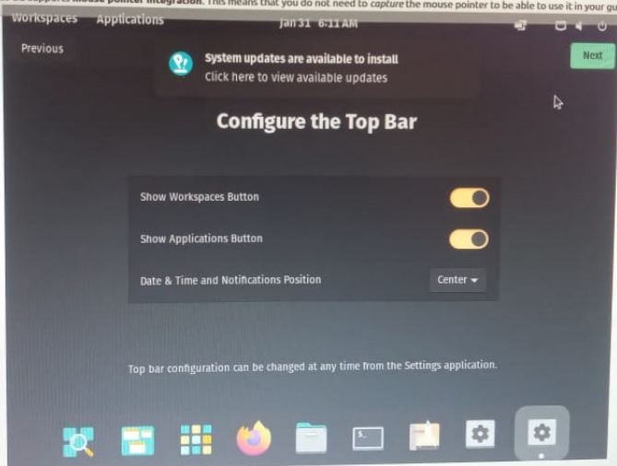

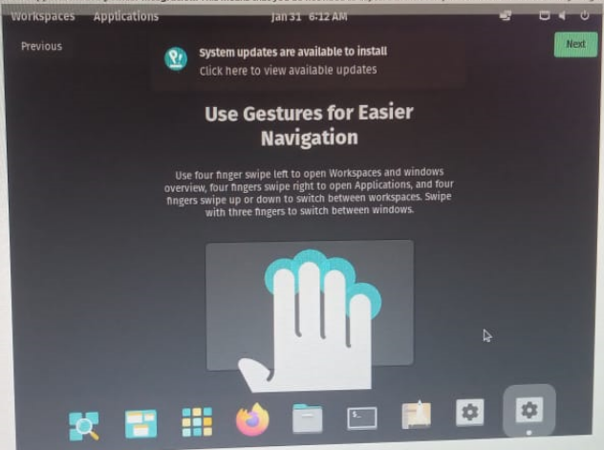

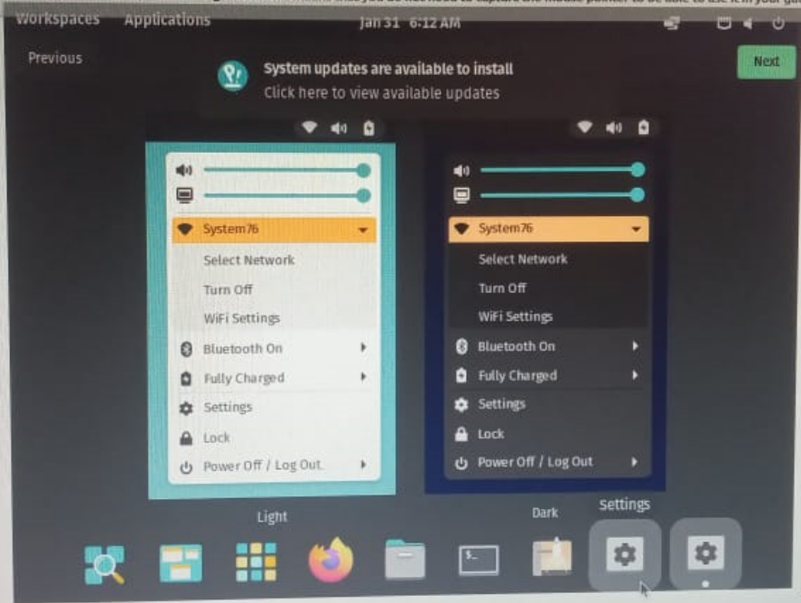

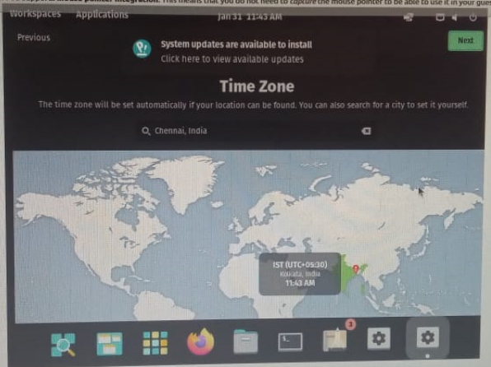

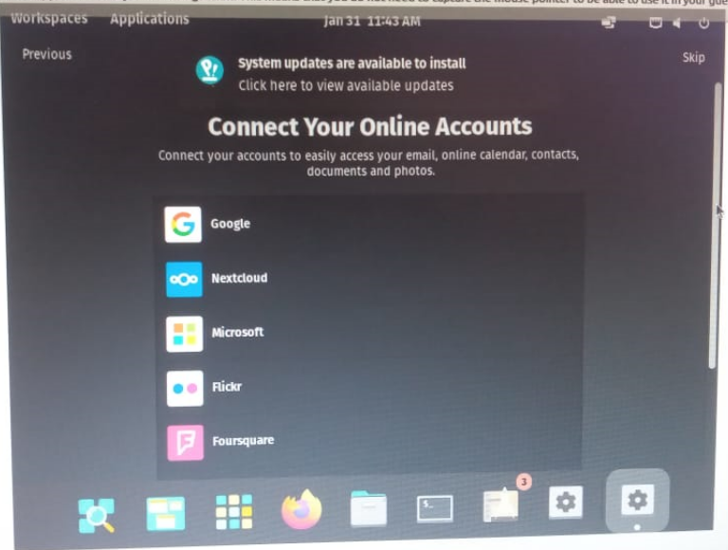

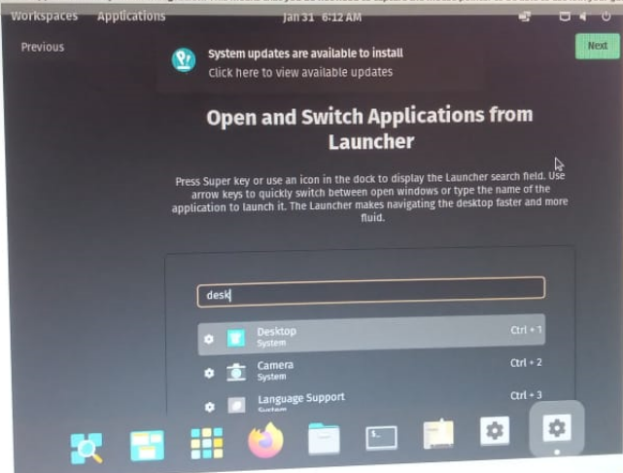

**Click on the checkbox and Press Enter**

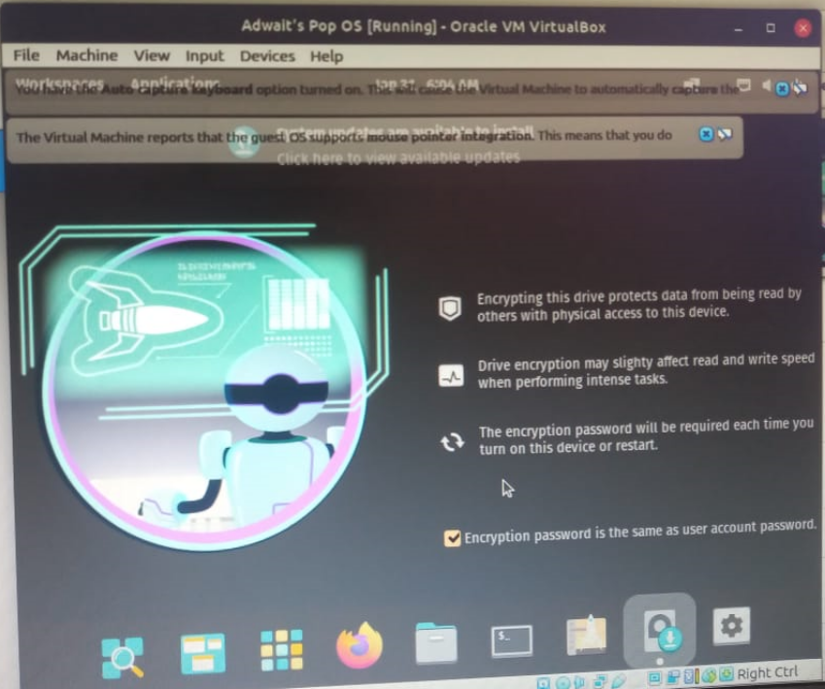

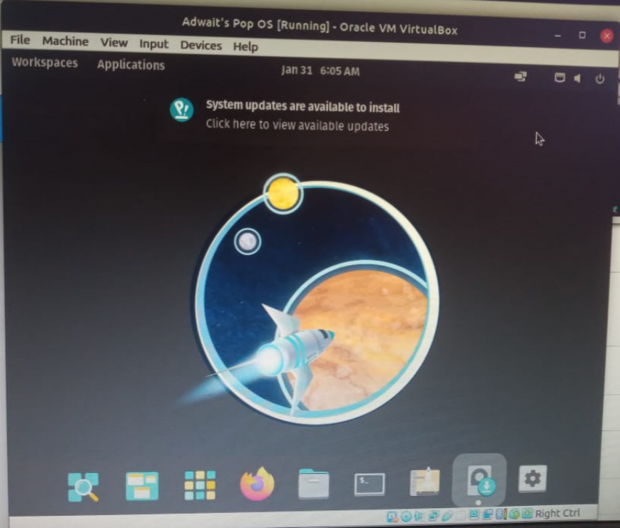

**GUI of Pop OS**

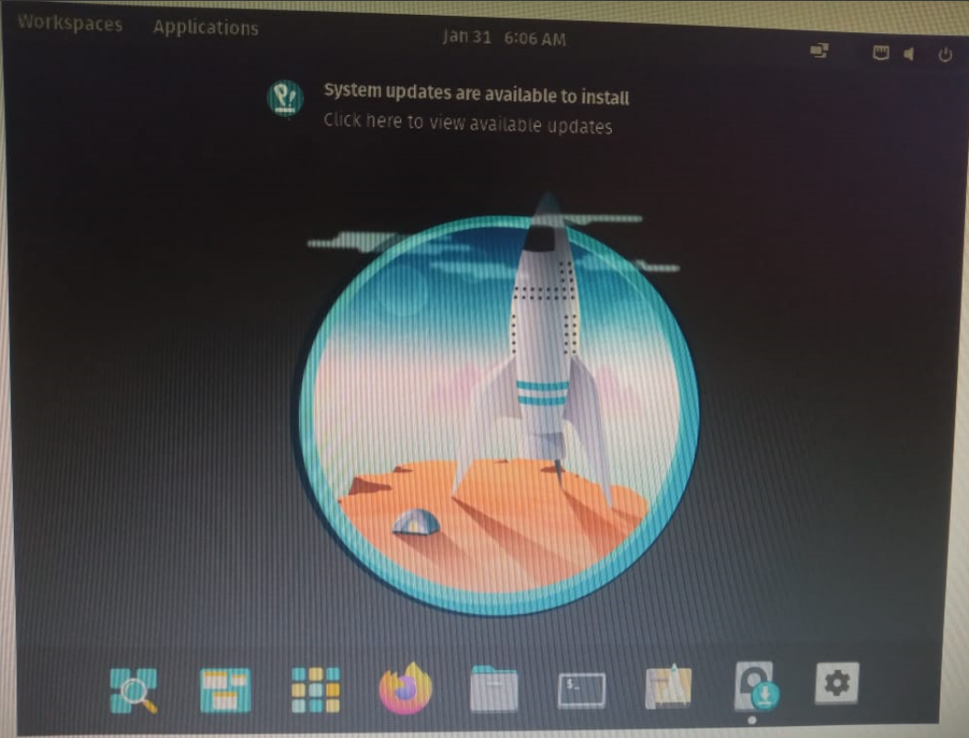

**Checking whether the file manager is working or not**

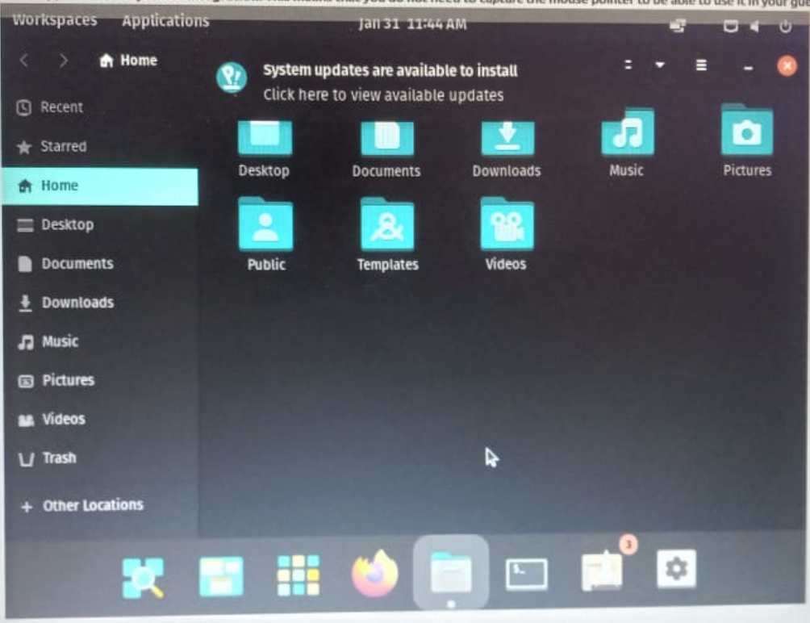

**Toggling the volume**

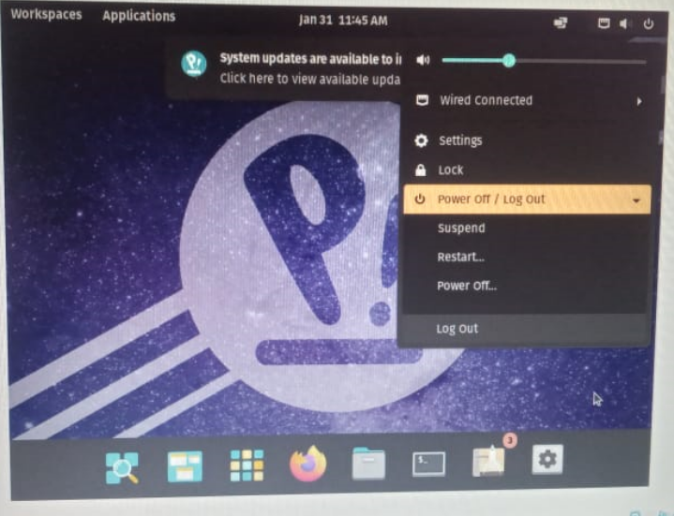

**Turning power off**

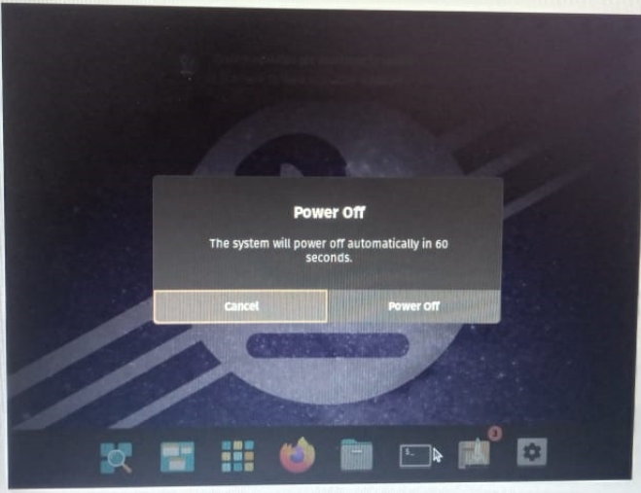

**Conclusion:**

**I installed Pop OS of Linux from Chrome . I also ran Utility , Networking , File and Directory commands on Linux Terminal . I installed WSL in my own desktop and resolved the error which occurred while create new file or copying from one location to the other , by using “sudo” before each linux command . I also learnt about virtual machine in this experiment.**